**How to raise ticket from “Help”**

**Step 1**: Click on “Help” from your LMS portal.

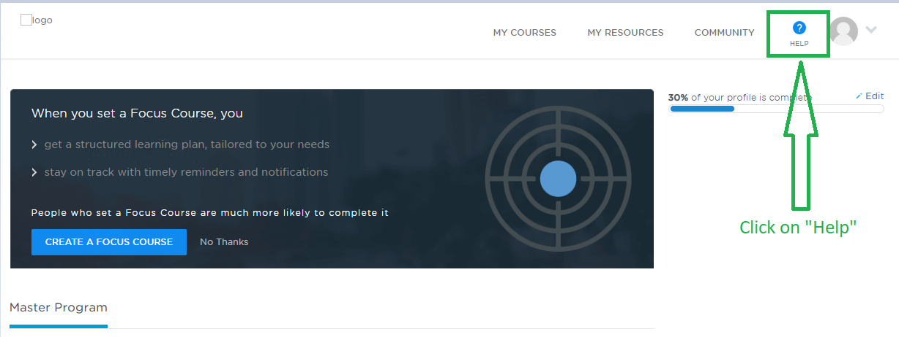

**Step 2**: It would take couple of seconds to get the chat popup window. Click on any one question.

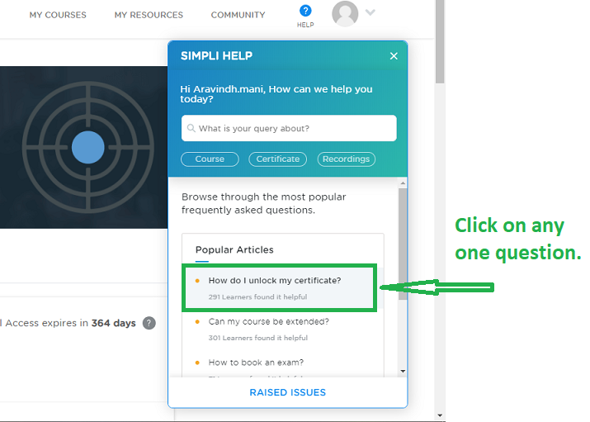

**Step 3**: Once you click on any one question, you will find the answer for the same and then click on “NO” (When it asks “Was it helpful”).

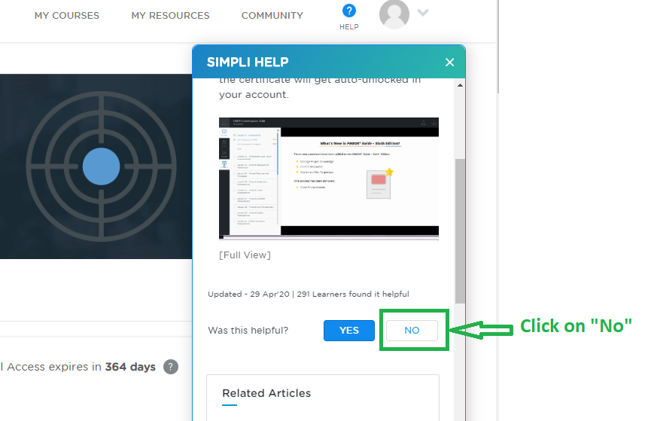

**Step 4:** Click on Connect to Arya.

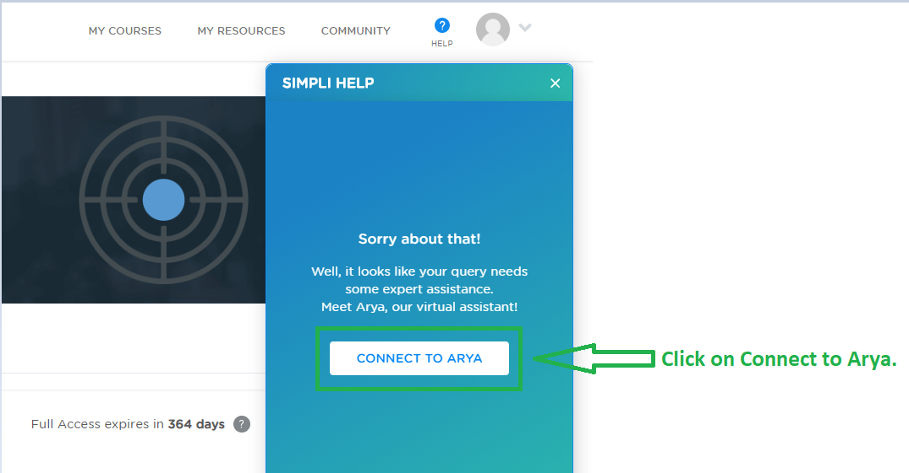

**Step 5:** Click on “other”.

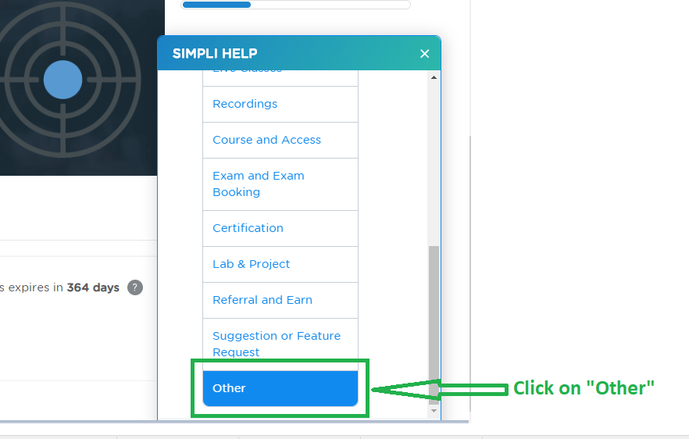

**Step 6:** Click on “Yes”.

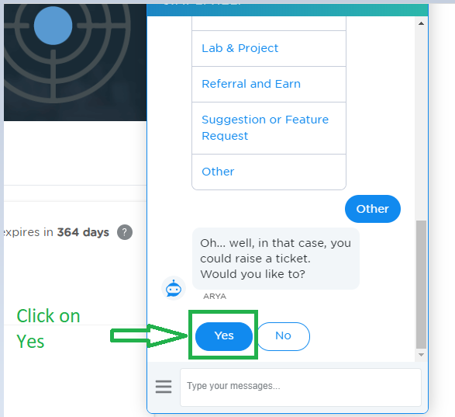

**Step 7:** Explain the exact issue, attach if you have any screenshots and click on Submit.

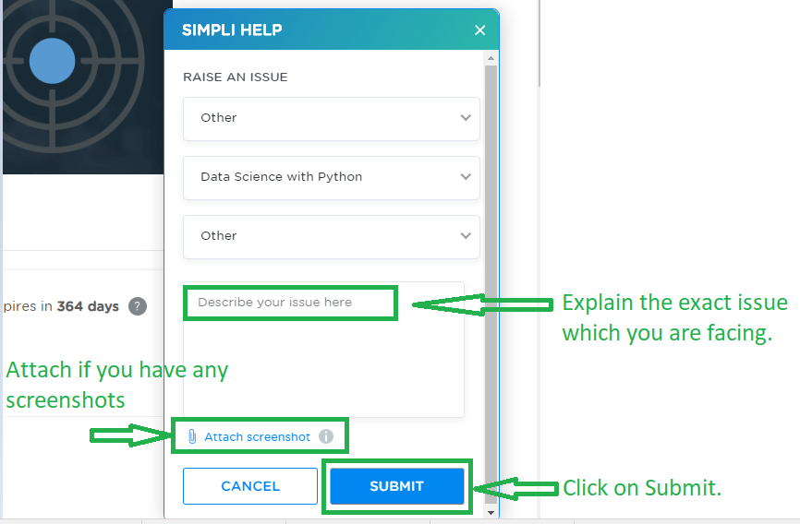

Step 8: Your ticket has been raised.

